**Error Detection and Handling assignments**

1. WAP to read atleast 2 designation strings from the user. Using assert validate

i. Count of received designation strings

ii. Value of each string as one of {“E2”, “E3”, “E4”}

Failure of any of tested condition in i) or ii) should terminate program. On success should display the received valid designations

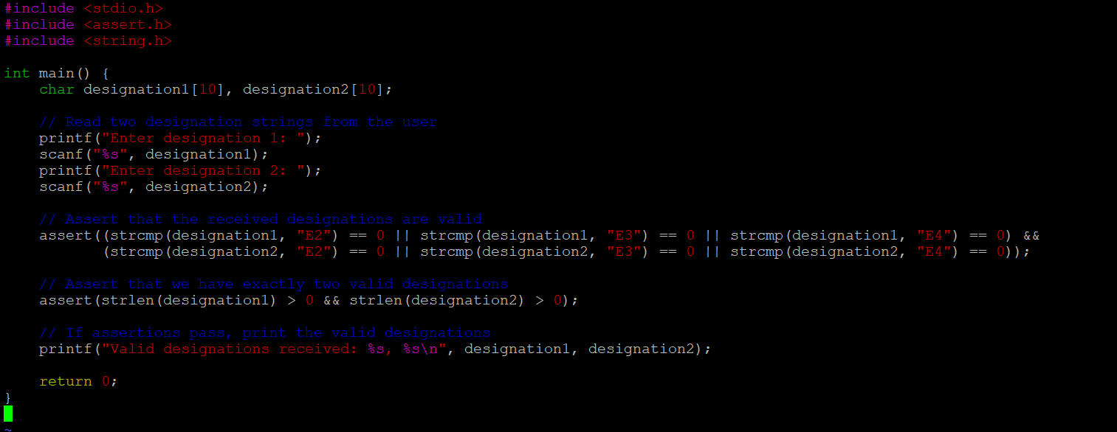

2. Refer the code below. Modify code to use assert instead of if else. Add main and invoke function() and test it

void function(int x)

{

float fx;

if (x==0)

{

printf("Division by Zero is not allowed");

fprintf(stderr, "Division by zero! Exiting...\n");

exit(EXIT_FAILURE);

}

else

{

fx = 10 / x;

printf("f(x) is: %.5f", fx);

}

}



